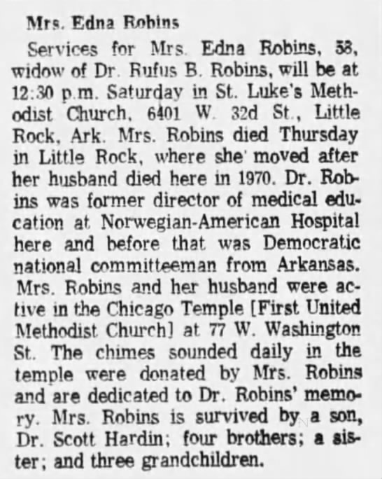

1. [Chicago Tribune](https://www.newspapers.com/browse/US/Illinois/Chicago/Chicago%20Tribune_4351),
2. [13 Sep 1980, Sat](https://www.newspapers.com/browse/US/Illinois/Chicago/Chicago%20Tribune_4351/1980/09/13),
3. [Other Editions](https://www.newspapers.com/browse/US/Illinois/Chicago/Chicago%20Tribune_4351/1980/09/13/Other%20Editions),
4. [Page 113](https://www.newspapers.com/image/386977185/)

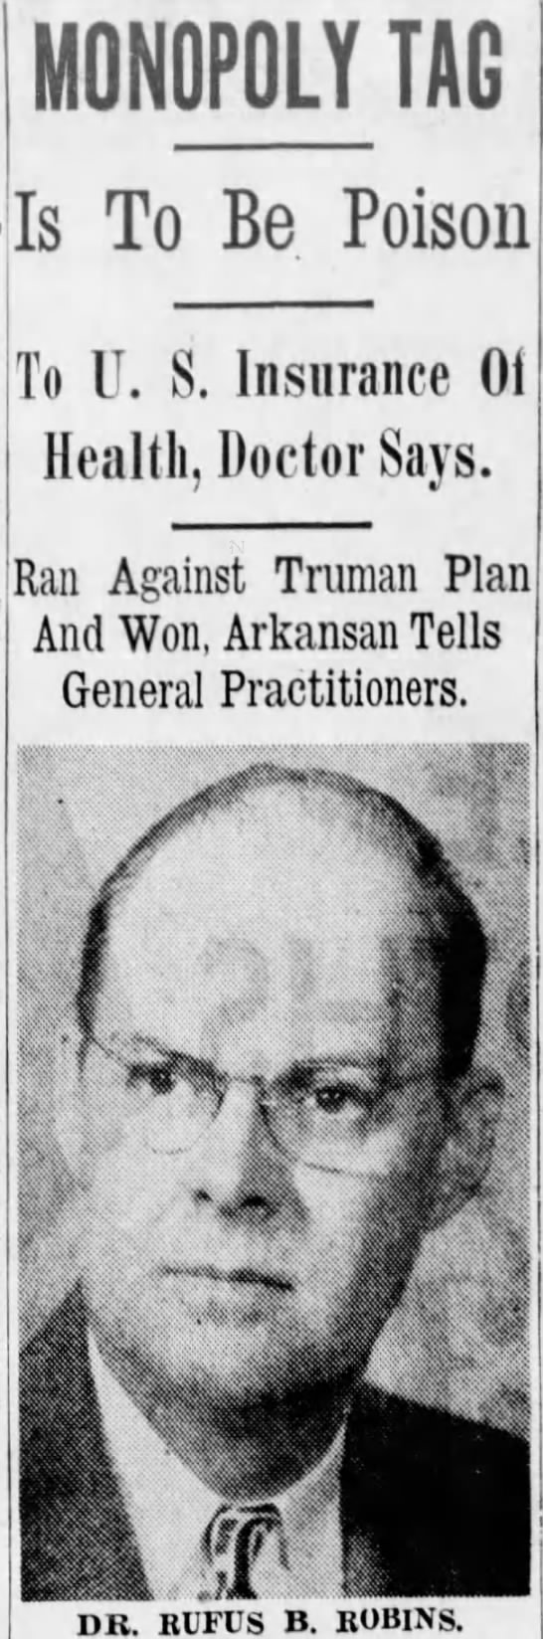

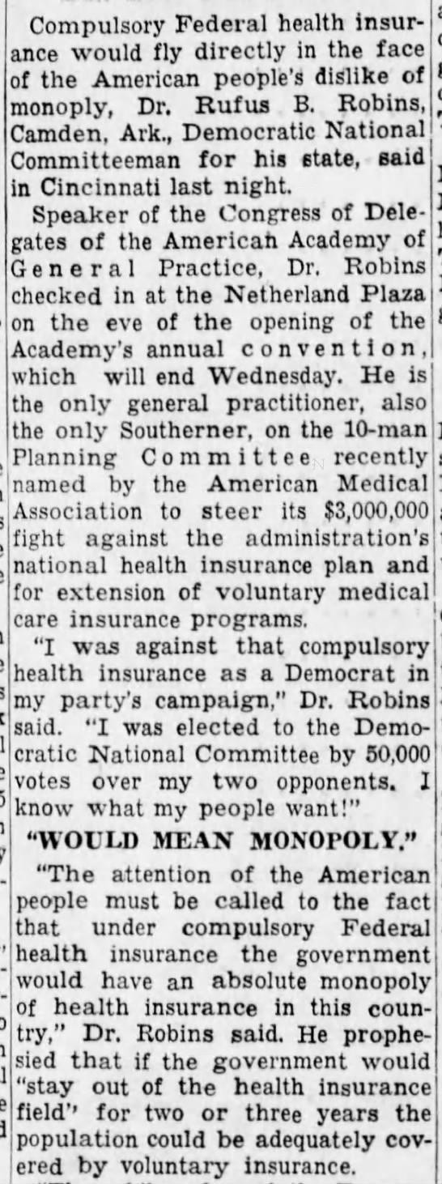

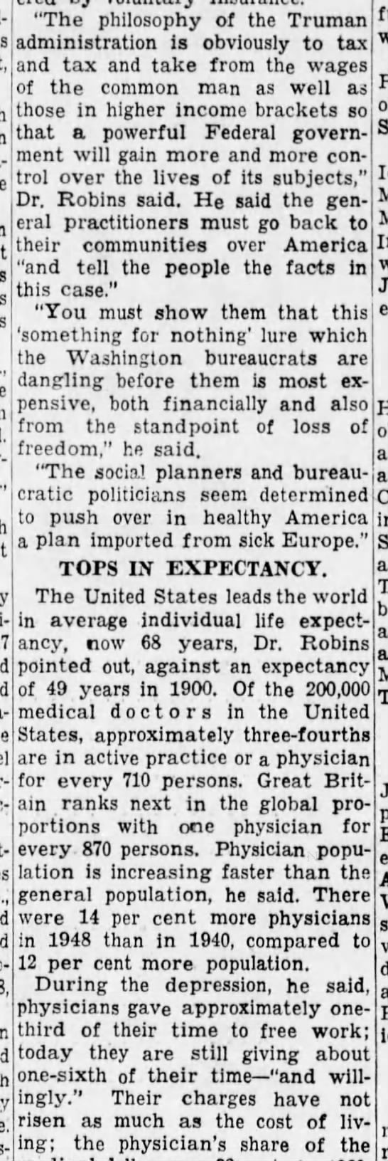

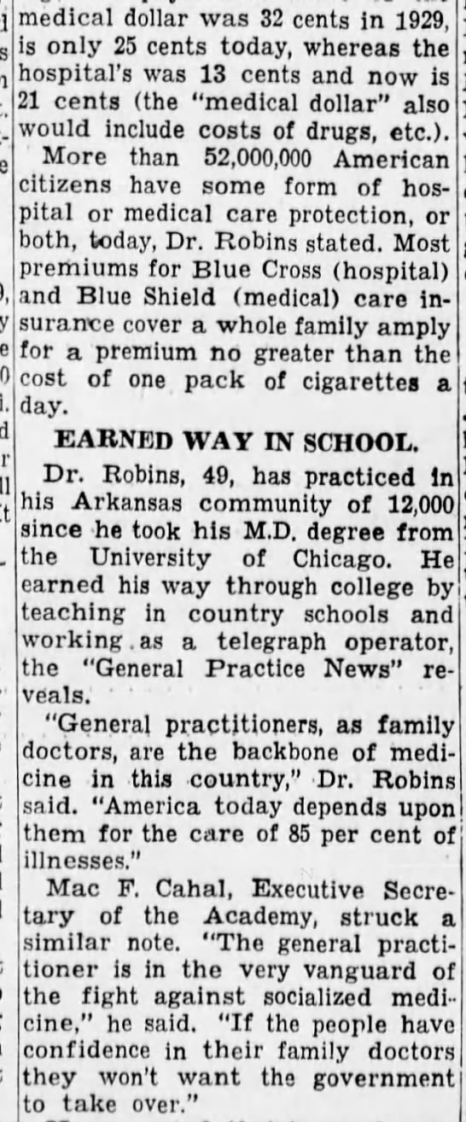

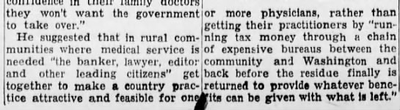

**Cincinnati Enquirer, March 6, 1949, p. 6**