Article about Dr. Robins’ mother dying in a car accident

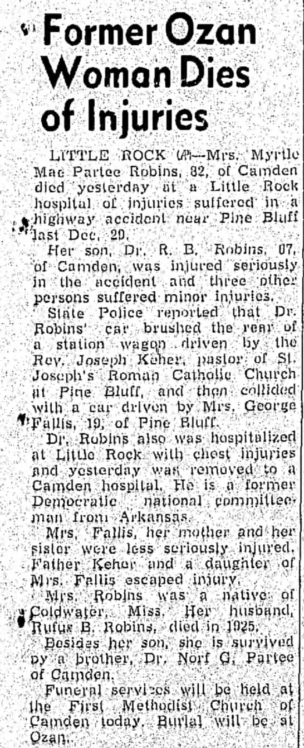 January 8, 1958 Hope Star of Hope, Arkansas

