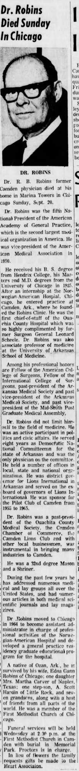 The Camden News, September 21, 1970

