12/28/1962

Dearly Beloved:
I’m home from Argentum. Had a visit with Dick and Burrus. It was very crowded and noisy. There was a large party at which George Meany was present.
I was alone most of the evening. I got to thinking. I’m not only missing you more and more, but I’m missing a way of life I once had. In my university days, when I was going with my scientist who was of world renown, I had social and professional status such as I have not had since. I knew and met scientists from all over the world. I had a personal mailing list of 200 leading scientists with whom I exchanged scientific publications and to whom I wrote. I was a fellow of the Geological Society of America, Paleontological Society of America, and American Academy of Sciences by the time I was 27 or 28, all on the basis of my original contributions to science. I was in Who’s Who in America and in American Men of Science. I had the world before me. I went to gatherings of distinguished men and women and was accepted on a par. When there was a reception for Madame Curie, I was an invited guest. I went to scientific gatherings and was accepted socially and professionally. When a scientific society, of which I was a fellow – and only 7 women in N. America were fellows, I went to the inner sanctum of the Cosmos Club in Wash. where women are NEVER permitted.
After I broke with my scientist and sent him to a high post in Asia in one of the world capitals, he begged me to join him and marry him. He described the home we would have, the life we would lead. Leaders in science from all over the world visited the university where he was head of a dept. There were parties and receptions where I would have been accepted with honor in my own right and as the wife of a famous scientist. I would have had travel in the Orient. It was the life for which I was made. And I refused and refused solely because he had lied to me in one small area. I’ve thought since – not that it does me any good – that I was too intransigent. I had been brought up to think that a lie was disgraceful and unacceptable to God. I felt that if a man would lie to me about anything at all, I could never trust him. I broke my own heart and his too when I broke with him. We were so perfectly attuned, physically, intellectually, and socially. A friend of mind went on a world trip and visited my scientist. She said his room was full of pictures of me and that he talked and talked of me.
I got to thinking of all this tonight as I realized the barrenness of my existence. I have no acceptance by the medical profession. I never go to any important meetings where I am accepted socially and intellectually. Quite aside from my loneliness for you, I am lonely for social and intellectual acceptance. This business of going to Argentum and engaging in small talk with Helen and the other musicians is not truly satisfying.
When I married B., I dropped into a different world. He had spent his life as a clerk in an insurance company. He had a high school education. I later gave him five years at college, but he didn’t get his degree. I broke completely with my former life. No more science. No more meetings. I lost my fellowships for lack of payment of dues. I settled down into a half life and made the best of things. We didn’t go anywhere or see anyone. We spent our evenings at home together long before he became an invalid. My social and intellectual potentials were crushed and remained so throughout our marriage – half my life.
Not I find all the old yearnings coming to the fore. I have a certain sort of fun at Silver Fox, but what a shadowy thing it is to what I have had. I see women who have nothing intrinsically moving in circles where I know I could shine because I have shone in the past. They moved in those circles by virtue of being married to an important man. I don’t dwell too much on the past because it is a futile occupation. But I sometimes feel I boobed up my life completely, sacrificing everything on the altar of TRUTH. To what end?
Sometimes I think you understand what I say. But at other times I think you don’t understand one solitary thing about women . . . Dear me, how did I get into such a mood? I’m lonely and unhappy and trying to think if it is at all possible to improve my life at this late hour.
I read today that the Russians were searching for oil in Cuba. Gracious! Forty years ago I did the basic scientific work on the ammonites of Cuba. I spent five years describing a Jurassic fauna and tracing it stratigraphically to the oil bed in Mexico. I could have made a fortune as an oil geologist had I been money-minded. I wasn’t. I did the scientific research and let others capitalize on my work.

Note: This letter ends without closing. The next letter is four days later, about finances, politics, etc.

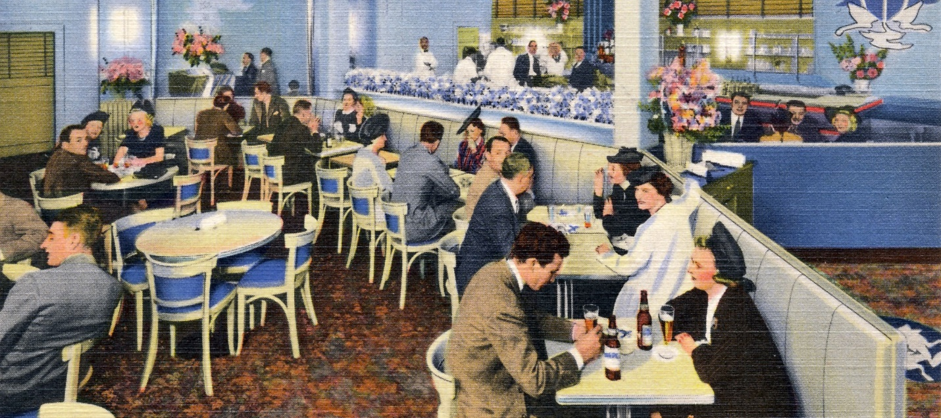
The Silver Fox Restaurant (Argentum) on Wisconsin Avenue in Friendship Heights

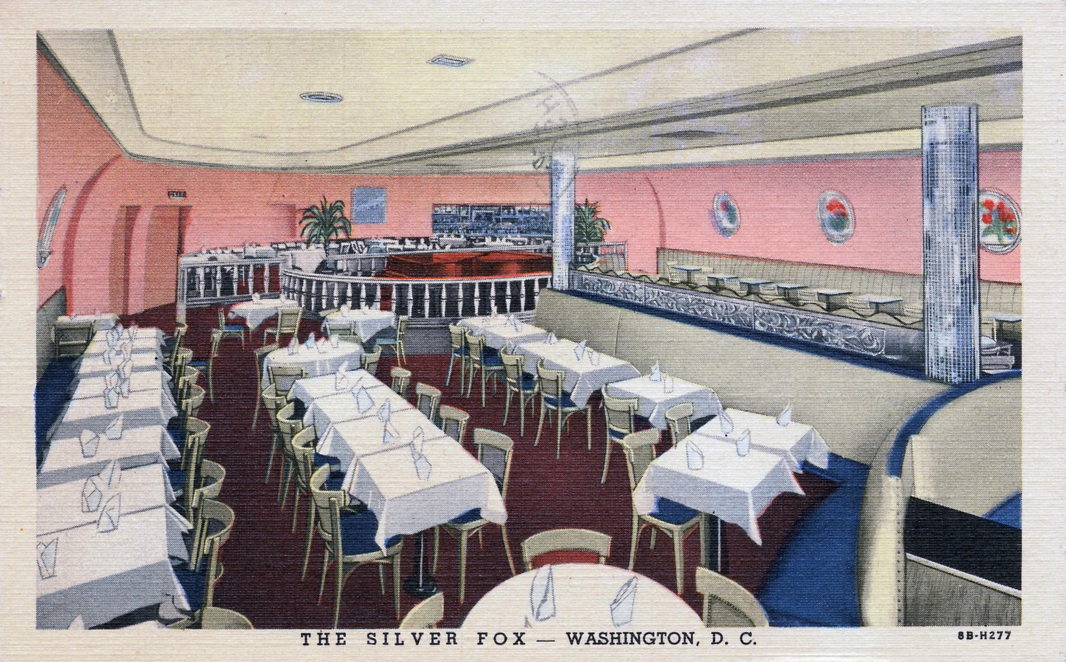
https://www.flickr.com/photos/streetsofdc/8746581569
“The Silver Fox was at 5324 Wisconsin Avenue NW in Friendship Heights. This jazzy nightclub was established by James Speros (1893-1985), a Greek immigrant, in 1945 and lasted until the 1970s. It served steakhouse fare. Another postcard view of the Silver Fox is in our banner. From the Facebook page “Historic Restaurants of Washington, D.C., capital eats” https://www.facebook.com/HistoricRestaurantsOfWashingtonDC/

Photo of the Silver Fox, outside at night: 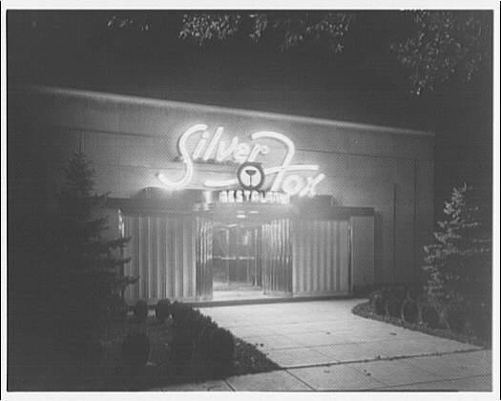

About this Item
Title
Silver Fox Restaurant, 5324 Wisconsin Ave. Exterior of Silver Fox Restaurant at 5324 Wisconsin Ave.
Contributor Names
Horydczak, Theodor, approximately 1890-1971, photographer
Created / Published
1948 Sept. 1.
Subject Headings
- Restaurants.
- United States--District of Columbia--Washington (D.C.)
- District Of Columbia--Washington (D.C.)
Format Headings
Acetate negatives.
Notes
- Item title devised.
- Logbook and subject card annotation: Todd Ewin.
Medium
1 negative : safety ; 8 x 10 in.
Call Number/Physical Location
LC-H814- 2594-001 [P&P;]
Source Collection
Horydczak, Theodor, ca. 1890-1971. Theodor Horydczak Collection (Library of Congress)
Repository
Library of Congress Prints and Photographs Division Washington, D.C. 20540 USA
Digital Id
thc 5a43301 //hdl.loc.gov/loc.pnp/thc.5a43301
Control Number
thc1995008627/PP
Reproduction Number
LC-H814-T-2594-001 (interpositive)
Rights Advisory
Publication may be restricted. For information see "Horydczak Collection" (http://lcweb.loc.gov/rr/print/res/100_hory.html)
Online Format
image
Description
1 negative : safety ; 8 x 10 in.

https://www.loc.gov/rr/print/res/100_hory.html

Silver Fox (5324 Wisconsin Ave., NW)
This 1961 menu features Moscow mules and whisky sours alongside lobster thermidor and tenderloin of beef bordelaise.
